Experiment No-: 1

Step 1 : Install java jdk 8

First of all you must install Java JDK 8 on your system. You can just type this command to install java jdk on your system.
sudo apt install openjdk-8-jdk

To check it’s there cd /usr/lib/jvm ls
clear
sudo nano .bashrc

Step 2 : Add this configuration on you bash file

Now just open .bashrc file and paste these commands. Use cntrl+shift+v and cntrl+o to write enter cntrl+x to exit
export JAVA_HOME=/usr/lib/jvm/java-8-openjdk-amd64 export PATH=$PATH:/usr/lib/jvm/java-8-openjdk-amd64/bin export HADOOP_HOME=~/hadoop-3.2.3/
export PATH=$PATH:$HADOOP_HOME/bin export PATH=$PATH:$HADOOP_HOME/sbin export HADOOP_MAPRED_HOME=$HADOOP_HOME
export YARN_HOME=$HADOOP_HOME
export HADOOP_CONF_DIR=$HADOOP_HOME/etc/hadoop
export HADOOP_COMMON_LIB_NATIVE_DIR=$HADOOP_HOME/lib/native export HADOOP_OPTS="-Djava.library.path=$HADOOP_HOME/lib/native"
export HADOOP_STREAMING=$HADOOP_HOME/share/hadoop/tools/lib/hadoop-streaming- 3.2.3.jar
export HADOOP_LOG_DIR=$HADOOP_HOME/logs export PDSH_RCMD_TYPE=ssh

install ssh( ssh — secure shell — protocol used to securely connect to remote server/system — transfers data in encrypted form)
sudo apt-get install ssh

now go to hadoop.apache.org website download the tar file (hadoop.apache.org — download tar file of hadoop.)
tar -zxvf -/Downloads/hadoop-3.2.3.tar.gz and press enter

(Extract the tar file) cd hadoop-3.2.3/

cd etc/hadoop
/ ls

sudo nano hadoop-env.sh JAVA_HOME=/usr/lib/jvm/java-8-openjdk-amd64
now open hadoop-env.hsudo nano hadoop-env.hJAVA_HOME=/usr/lib/jvm/java-8- openjdk-amd64 (set the path for JAVA_HOME)

cntrl+shift+v and cntrl+o to write enter cntrl+x to exit

Step 3 : Add this file in core-site.xml
sudo nano core-site.xml
Now add this configuration in core-site.xml file.

core-site.xml
<configuration>
<property>
<name>fs.defaultFS</name>
<value>hdfs://localhost:9000</value> </property>
<property>
<name>hadoop.proxyuser.dataflair.groups</name> <value>*</value>
</property>
<property>
<name>hadoop.proxyuser.dataflair.hosts</name> <value>*</value>
</property>
<property>
<name>hadoop.proxyuser.server.hosts</name> <value>*</value>
</property>
<property>
<name>hadoop.proxyuser.server.groups</name> <value>*</value>
</property>
</configuration>

Step 3 : Add this file in hdfs-site.xml
Now add this configuration in hdfs-site.xml file. sudo nano hdfs-site.xml

hdfs-site.xml
<configuration>
<property>
<name>dfs.replication</name>
<value>1</value>
</property>
</configuration>

Step 4: Add this file in mapred-site.xml
Now add this configuration in mapred-site.xml file. sudo nano mapred-site.xml

mapred-site.xml
<configuration>
<property>
<name>mapreduce.framework.name</name> <value>yarn</value>
</property>
<property>
<name>mapreduce.application.classpath</name>

<value>$HADOOP_MAPRED_HOME/share/hadoop/mapreduce/*:$HADOOP_MAPRED_HOME/share/ hadoop/mapreduce/lib/*</value>
</property>
</configuration>

Step 4: Add this file in yarn-site.xml
Now add this configuration in yarn-site.xml file. sudo nano yarn-site.xml

yarn-site.xml
<configuration>
<property>
<name>yarn.nodemanager.aux-services</name>
<value>mapreduce_shuffle</value>
</property>
<property>
<name>yarn.nodemanager.env-whitelist</name>

<value>JAVA_HOME,HADOOP_COMMON_HOME,HADOOP_HDFS_HOME,HADOOP_CONF_DIR,CLASSPATH_P REP END_DISTCACHE,HADOOP_YARN_HOME,HADOOP_MAPRED_HOME</value>
</property>
</configuration>

ssh localhost
ssh-keygen -t rsa -P '' -f ~/.ssh/id_rsa
cat ~/.ssh/id_rsa.pub >> ~/.ssh/authorized_keys chmod 0600 ~/.ssh/authorized_keys
hadoop-3.2.3/bin/hdfs namenode -format

format the file system
export PDSH_RCMD_TYPE=ssh

Step 5 : Start hadoop

To start
start-all.sh(Start NameNode daemon and DataNode daemon)

localhost:9870 codewitharjun@cwa:~$ hadoop fs -mkdir /user
codewitharjun@cwa:~$ hadoop fs -mkdir /user/arjun.gautam codewitharjun@cwa:~$ touch demo.csv
codewitharjun@cwa:~$ hadoop fs -put demo.csv /user/arjun.gautam stop-all.sh

This is how you can install hadoop on your ubuntu operating system and start using on your system.

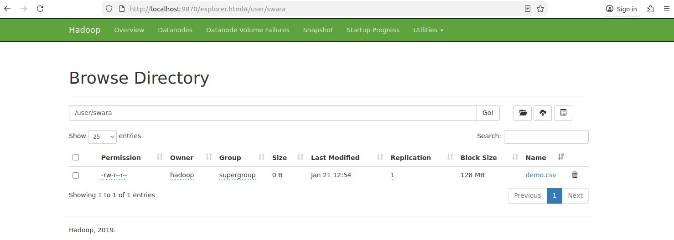

Output-:

